Kit 22: 8x16 RGB Matrix Blinkie

The heart of this blinkie is a 18F25K50 PIC produced by a company called Microchip. A PIC is a tiny, yet surprisingly powerful little computer. By itself, it can’t do much – it needs someway to interact with the world – we are going to do this by giving it senses:

- Touch – two push buttons  and ways to communicate:  - To us – 128 RGB light emitting diodes (LEDs).  - To a computer via USB. | 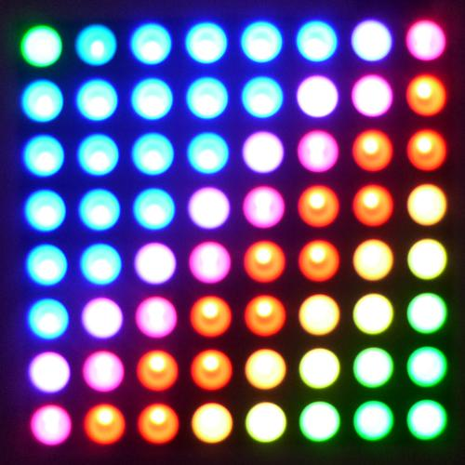

By building this blinkie, we hope you have a lot of fun, as well as learn how easy it is to assemble and solder a circuit, as well as gain a desire to learn more!

Use

Once built, the use of this blinkie is fairly straightforward. Don’t get it wet. Don’t stick it in a pocket with a bunch of car or house keys where it might short out.

This blinkie has additional patterns stored in the micro SD card. To change patterns, press the push button and hold. The topmost LED will light, and then the LEDs will count up (or down) in a sequence. Each sequence represents a stored pattern. If the push button is released, the pattern associated with that particular binary number will then be displayed on your blinkie.

The blinkie has two display modes. Demo, where it will switch to a different stored pattern every minute, as it cycles through all the stored patterns. Normal, where will continue to display the current pattern until a new pattern is selected via the push buttons. To toggle between the modes, hold down both push buttons.

Now, on to the assembly…
First, open up the kit and review the contents. Looking from left to right, and top to bottom there should be the following parts:

- 16x8 RGB matrix circuit board  - Two 8x8 RGB LED matrixes  - Four 16 pin single header sockets  - Two 0.1 uF disk capacitors (104)  - Three 220 uF electrolytic capacitors  - Three AAA battery holders  - Three AAA batteries  - Three 1K ohm resistors (brown, black, red)  - Two 27K ohm resistors (red, violet, orange)  - Diode  - Coil (green ceramic body)  - Micro SD card circuit board module  - Micro SD card  - 6 pin single header  - USB socket  - Power switch  - Two push buttons  - Three 24 pin MBI15026GN LED drivers  - Three 24 pin sockets  - 8 pin MAX756 charge pump  - 8 pin socket18 pin  - 18 pin TD62783APG LED driver  - 18 pin socket  - 28 pin 18F25K50 PIC  - 28 pin socket | 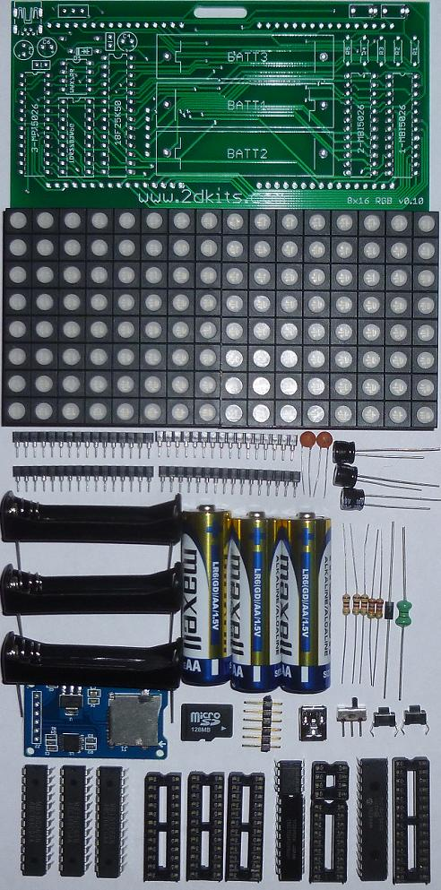

Got everything to start? If not, give us a shout. Next, a few words on soldering…

Soldering Hints

Soldering is not like gluing; the solder forms an alloy with the metals to be connected that creates a stable electrical path and a certain amount of mechanical attachment. For the small connections on this project, a 25 or 30 watt soldering iron works well. Rosin core solder is used – the acid core solder sold for plumbing would eat your components in a short time.

Here’s how to make a good joint:
- Prepare the joint. Bend the component lead slightly after it passes through the printed circuit board (this helps hold it in place while soldering).
- Prepare the tool. The soldering iron should be up to temperature. Clean the tip by quickly brushing it against a dry wire pad, or damp sponge, or damp cloth. Melt a little solder (a 2mm length) onto the tip so it’s shiny. This is called “tinning”. The solder coating helps conduct heat from the tip to the joint.
- Place the tip in contact with the component lead and the printed circuit board pad.
- Place the solder against the joint directly opposite the tool. It should melt within 2 seconds, and flow around the joint. If it takes longer than that, you’re not getting enough heat into the joint.
- Keep the soldering iron in place until the solder flows freely and completely covers the joint. If the heat is removed too soon, the solder will tend to “ball up” and not stick well to the conductors. The solder joint should look "wetted”, with concave shapes.
- Let the joint cool without movement at room temperature. This usually takes only a few seconds.
- If a joint is moved before it cools, it will take on a dull, satin look that is characteristic of a cold solder joint. A cold solder joint is fragile and conducts poorly – reheat the joint until the solder flows freely, and hold it still until it cools.
- Keep the tip of the soldering iron clean. Wipe off flux and excess solder regularly in the damp sponge or cloth, and re-tin if needed.
A suggestion on trimming leads (the excess wire visible after soldering). Hold your finger over the ends of each lead to keep it from flying off when cut. | 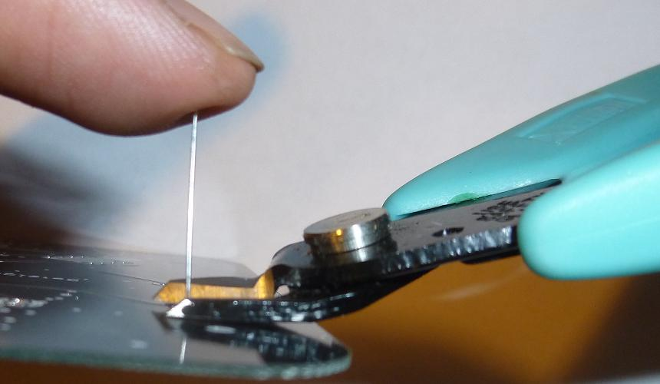

Assembly

Hopefully, you will read the instructions before soldering parts in place. By following the steps in order, the soldering of other components may be significantly easier.

Ready to start? First, some preliminary assembly is required before starting on the main board.

- Insert the 16 pin single header sockets onto the 8x8 RGB LED matrixes. Each matrix will use two headers. It makes it much easier to align the 8x8 RGB LED matrixes when they are soldered into the board. The matrix fits very snugly into the headers – be patient and slowly work it into the headers. Or, it may just snap in. Either way, take your time. | 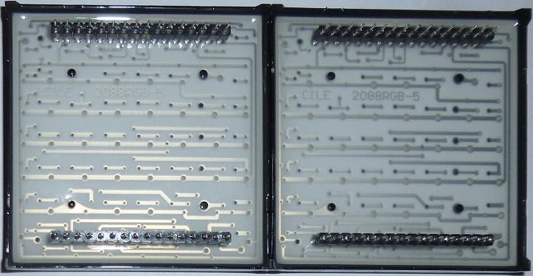

- Insert the 6 pin single header socket onto the backside (the side without any visible components) of the micro SD card module circuit board. The shorter end of the pins must be inserted into the micro SD card module circuit board. Flip the board over and solder.  - Insert the micro SD card. | 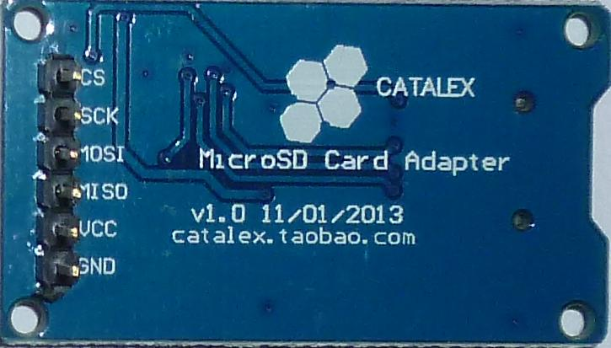

- Insert the resistors. To make inserting easier, pre-bend the lead like this: 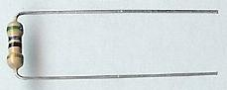  R1, R2, and R3 are 1K ohm (brown, black, red). R4 and R5 are 27K ohm (red, violet, orange). Flip the board over and solder. Flip the board over. | 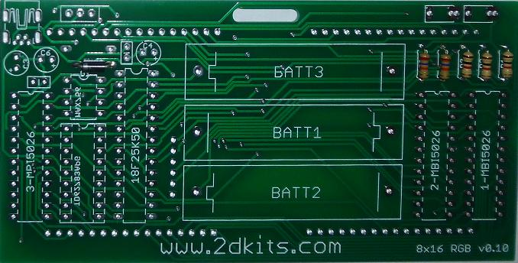

- Insert the diode at D1. To make inserting easier, pre-bend the leads as was done to the resistors. Orientation is important for diodes. There is a bar on the diode. It should be inserted so the bar is on the left, and it should match the silk screening. Flip the board over and solder. Trim all the leads and flip the board over.

- Insert the disk capacitors. They will be inserted on the upper left-hand portion of the circuit board. They can be inserted either way as orientation is not important for disk capacitors. Flip the board over and solder. Trim all the leads and flip the board over. | 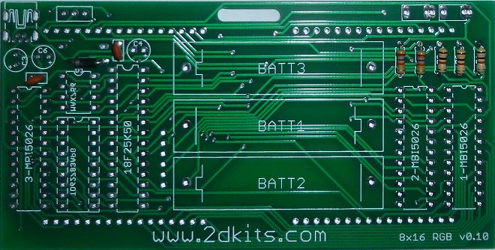

- Insert the electrolytic capacitors at C3, C4, and C6. Orientation is important for electrolytic capacitors. Remember: Short lead, square pad. Long lead, round pad. Also, the positive (long lead) will match up with the “+” silk screen marking. Flip the board over and solder. Trim all the leads and flip the board over. | 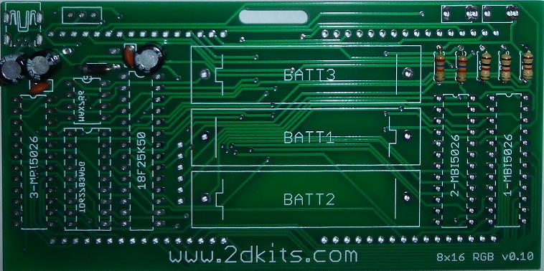

- Insert the sockets. The notches on all the sockets must face to the top of the board. To keep the sockets from falling out when flipped, bend over two of the pins after each one has been inserted. Flip the board over and solder all pins. Trim the leads. | 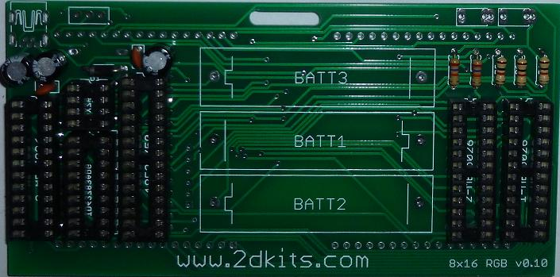

- Insert the coil at L2. The coil can be inserted either way as orientation is not important for the coil. To make inserting easier, pre-bend the leads as was done to the resistors. Flip the board over and solder. Trim the leads. | 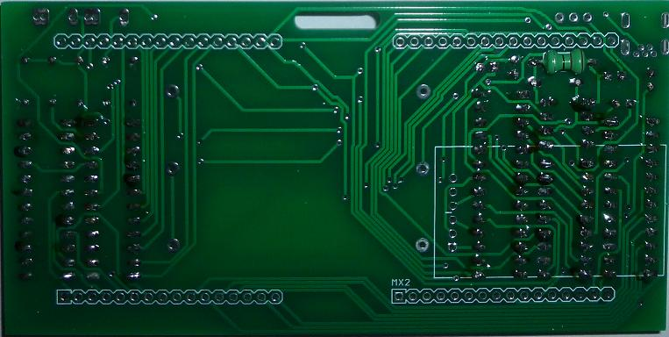

- Insert the micro SD card module circuit board. Flip the board over and solder. Trim the leads. | 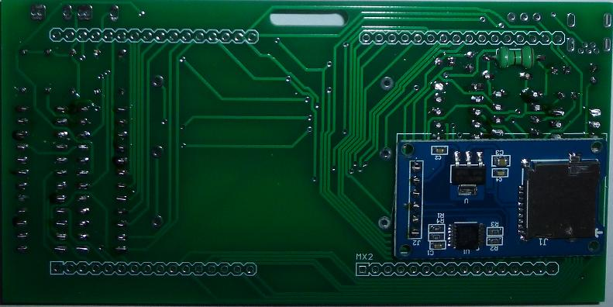

- Insert the battery holders. Orientation is important for the battery holders. They do not all go in the same direction. The first one, the spring goes to the right. The second one, the spring goes to the left. The third one, the spring goes to the right. Flip the board over and solder. Trim the leads. | 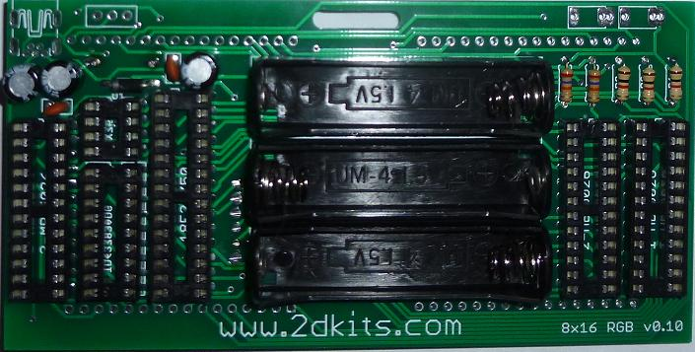

- Insert the push buttons into the board. Note that there are three holes – the push button being used will fit into the outermost holes. The push buttons will snap into place.  - Insert the USB socket and power switch. Flip the board over and solder all four components. Trim all the leads. | 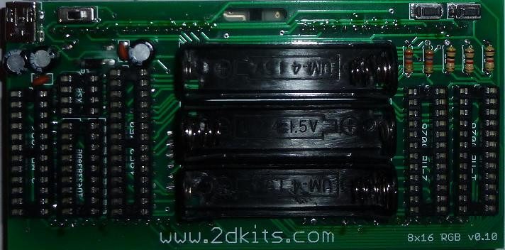

- Insert the 8x8 RGB matrixes, onto which the 16 pin single header sockets were inserted in Step 1. The best way to determine the correct orientation is to locate back printing (CILE 2088RGB05) – this indicates the orientation of the matrix. Flip the board over and solder. | 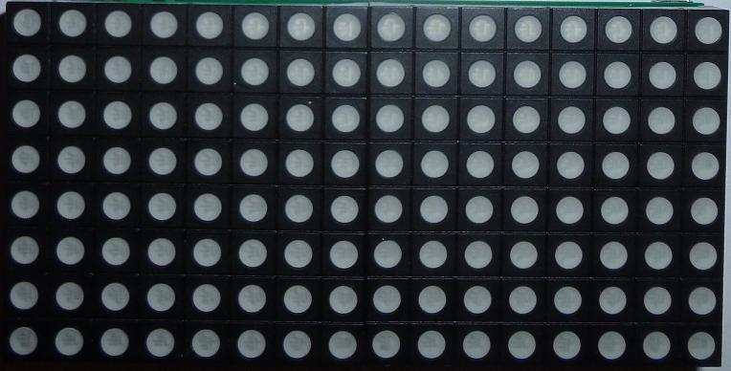

- Insert the chips. Moving from left to right, top to bottom: MBI15026GN, MAX756, TD62783APG, 18F25K50, MBI15026GN, and MBI15026GN. The notches on all the chips must face to the top. | 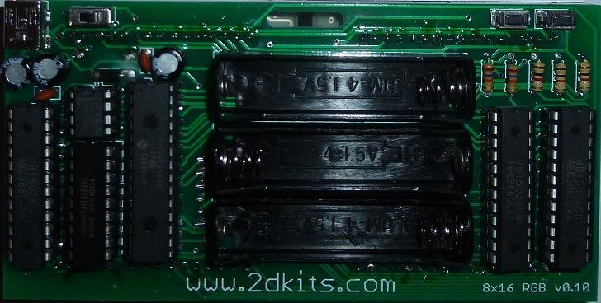

- Insert the three AAA batteries. Alternatively, connect to a USB charger *or* to a USB cable connected to a USB port. Turn on the board and enjoy. The length of battery life depends on the number of LEDs lit at any one time. If the patterns are looking less colorful, replace the batteries, or plug into a USB port. Note, the USB does *not* recharge the batteries. | 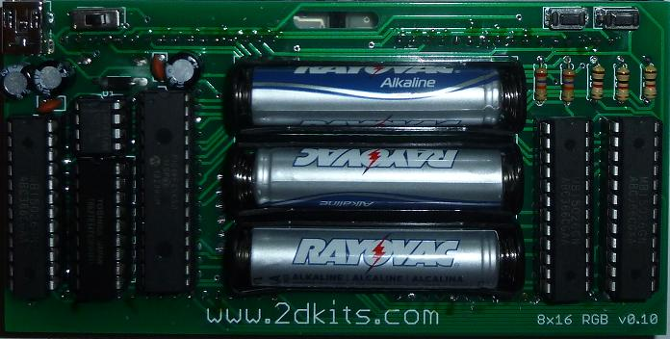

Troubleshooting

If the LEDs don’t flash, then you’ll need to do a little troubleshooting to finish your project. The following steps should isolate most problems.

- Recheck your solder connections. 80% of all problems are traced to this. Cold solder joints and broken joints will cause erratic performance or failure. Reheat any questionable solder connections until they flow and look shiny and secure.
- Check for bits of solder, wire ends, or other foreign matter which may be lodged in the wiring.
- LEDs reversed. You will need to remove the LED by desoldering, and then solder it in the correct way.
- Batteries incorrectly inserted.
- Bad part – it does happen. In the hundreds of boards assembled, we’ve seen two or three parts fail. Send us email, and we will send a replacement part.
- A part got lost/melted/damaged/destroyed while building the kit. It happens – you’re not the first (or second, or fiftieth). Send us email, and we’ll see what we can do. We have no problem selling just the parts you need to get it working.

